

**Artificial Intelligence and Data Science Department.**

AOA / Even Sem 2021-22 / Assignment 1 - Question 2.

YASH SARANG.

47 / D6AD.

ASSIGNMENT 1 - Question 2.

**___________________________________________________**

**Write a short note on the pros and cons of the Greedy Approach to devising an Algorithm.**

### Greedy algorithms have some advantages and disadvantages:

* It is quite easy to come up with a greedy algorithm (or even multiple greedy algorithms) for a problem. Analyzing the run time for greedy algorithms will generally be much easier than for other techniques (like Divide and conquer). For the Divide and conquer technique, it is not clear whether the technique is fast or slow. This is because at each level of recursion the size gets smaller and the number of sub-problems increases.
* The difficult part is that for greedy algorithms you have to work much harder to understand correctness issues. Even with the correct algorithm, it is hard to prove why it is correct. Proving that a greedy algorithm is correct is more of an art than a science. It involves a lot of creativity. Usually, coming up with an algorithm might seem to be trivial, but proving that it is actually correct, is a whole different problem.

**___________________________________________________**

**Explain Kruskal's and Prim's algorithms by giving a suitable example.**

***Kruskal’s algorithm for MST***

Given a connected and undirected graph, a spanning tree of that graph is a subgraph that is a tree and connects all the vertices together. A single graph can have many different spanning trees. A minimum spanning tree (MST) or minimum weight spanning tree for a weighted, connected, an undirected graph is a spanning tree with a weightless than or equal to the weight of every other spanning tree. The weight of a spanning tree is the sum of weights given to each edge of the spanning tree.

Below are the steps for finding MST using Kruskal’s algorithm

1. Sort all the edges in non-decreasing order of their weight.
2. Pick the smallest edge. Check if it forms a cycle with the spanning tree formed so far. If the cycle is not formed, include this edge.

Else, discard it.

1. Repeat step#2 until there are (V-1) edges in the spanning tree.

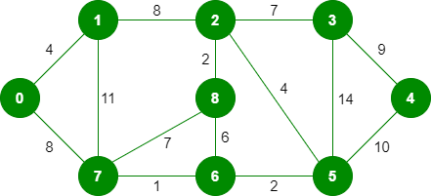

The graph contains 9 vertices and 14 edges. So, the minimum spanning tree formed will be having (9 – 1) = 8 edges.

After sorting:

Weight Src Dest

1 7 6

2 8 2

2 6 5

4 0 1

4 2 5

6 8 6

7 2 3

7 7 8

8 0 7

8 1 2

9 3 4

10 5 4

11 1 7

14 3 5

Now pick all edges one by one from the sorted list of edges

1. Pick edge 7-6: No cycle is formed, include it.

Kruskal’s Minimum Spanning Tree Algorithm

2. Pick edge 8-2: No cycle is formed, include it.

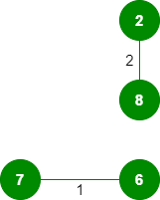

3. Pick edge 6-5: No cycle is formed, include it.

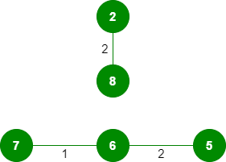

4. Pick edge 0-1: No cycle is formed, include it.

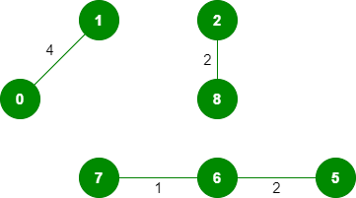

5. Pick edge 2-5: No cycle is formed, include it.

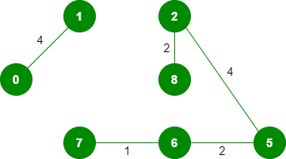

6. Pick edge 8-6: Since including this edge results in the cycle, discard it.

7. Pick edge 2-3: No cycle is formed, include it.

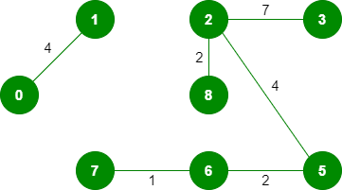

8. Pick edge 7-8: Since including this edge results in the cycle, discard it.

9. Pick edge 0-7: No cycle is formed, include it.

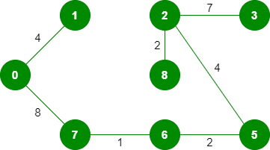

10. Pick edge 1-2: Since including this edge results in the cycle, discard it.

11. Pick edge 3-4: No cycle is formed, include it.

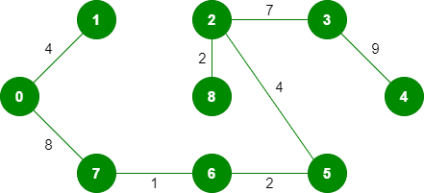

Since the number of edges included equals (V – 1), the algorithm stops here.

***Prim’s algorithm for MST***

Like Kruskal’s algorithm, Prim’s algorithm is also a Greedy algorithm. It starts with an empty spanning tree. The idea is to maintain two sets of vertices. The first set contains the vertices already included in the MST, the other set contains the vertices not yet included. At every step, it considers all the edges that connect the two sets and picks the minimum weight edge from these edges. After picking the edge, it moves the other endpoint of the edge to the set containing MST.

Below are the steps for finding MST using Prim’s algorithm

1. Create a mstSet that keeps track of vertices already included in MST.
2. Assign a key value to all vertices in the input graph. Initialize all key values as INFINITE. Assign the key value as 0 for the first vertex so that it is picked first.
3. While mstSet doesn’t include all vertices
   * Pick a vertex u which is not there in mstSet and has a minimum key value.
   * Include u to mstSet.
   * Update the key value of all adjacent vertices of u. To update the key values, iterate through all adjacent vertices. For every adjacent vertex v, if the weight of edge u-v is less than the previous key value of v, update the key value as the weight of u-v

Both Prim’s and Kruskal’s algorithm finds the Minimum Spanning Tree and follow the Greedy approach to problem-solving, but there are a few major differences between them.

Let us take the following example:

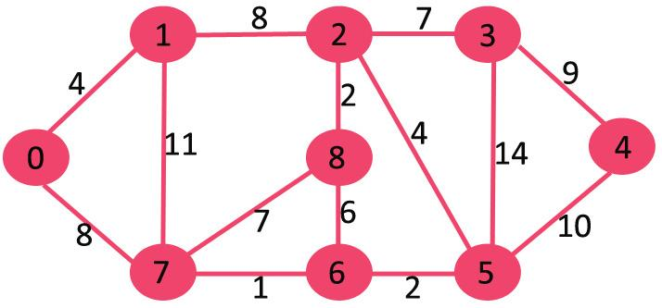

The set mstSet is initially empty and keys assigned to vertices are {0, INF, INF, INF, INF, INF, INF, INF} where INF indicates infinite. Now pick the vertex with the minimum key value. The vertex 0 is picked, include it in mstSet. So mstSet becomes {0}. After including to mstSet, update key values of adjacent vertices. Adjacent vertices of 0 are 1 and 7. The key values of 1 and 7 are updated as 4 and 8. The following subgraph shows vertices and their key values, only the vertices with finite key values are shown. The vertices included in MST are shown in green color.

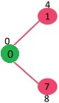

Pick the vertex with minimum key value and not already included in MST (not in mstSET). The vertex 1 is picked and added to mstSet. So mstSet now becomes {0, 1}. Update the key values of adjacent vertices of 1. The key value of vertex 2 becomes 8.

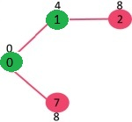

Pick the vertex with minimum key value and not already included in MST (not in mstSET). We can either pick vertex 7 or vertex 2, let vertex 7 is picked. So mstSet now becomes {0, 1, 7}. Update the key values of adjacent vertices of 7. The key value of vertex 6 and 8 becomes finite (1 and 7 respectively).

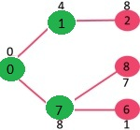

Pick the vertex with minimum key value and not already included in MST (not in mstSET). Vertex 6 is picked. So mstSet now becomes {0, 1, 7, 6}. Update the key values of adjacent vertices of 6. The key value of vertex 5 and 8 are updated.

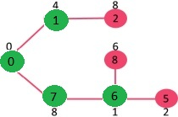

We repeat the above steps until mstSet includes all vertices of given graph. Finally, we get the following graph.



